INSTITUTO CAMBRIDGE – Exams 2024

KIDS 3

NAME:

2

TIME: 1 hour 30 minutes

MARK SET

WRITE THESE TEN WORDS IN GROUPS | 10 x 0.1 = 1 mark

curry playground cycle zoo skip fish noodles city surf chips

sail |  | skate park |  | burgers

CHOOSE AND CIRCLE | 5 x 0.2 = 1 mark

1 | Lily have / has dinner at 8 o’clock.
2 | Use / Don’t use your full name online.
3 | There is some / any spinach.
4 | The shoes wasn’t / weren’t on the rug.
5 | What / When does Ania play the violin?

READ AND WRITE TRUE OR FALSE | 5 x 0.3 = 1.5 marks

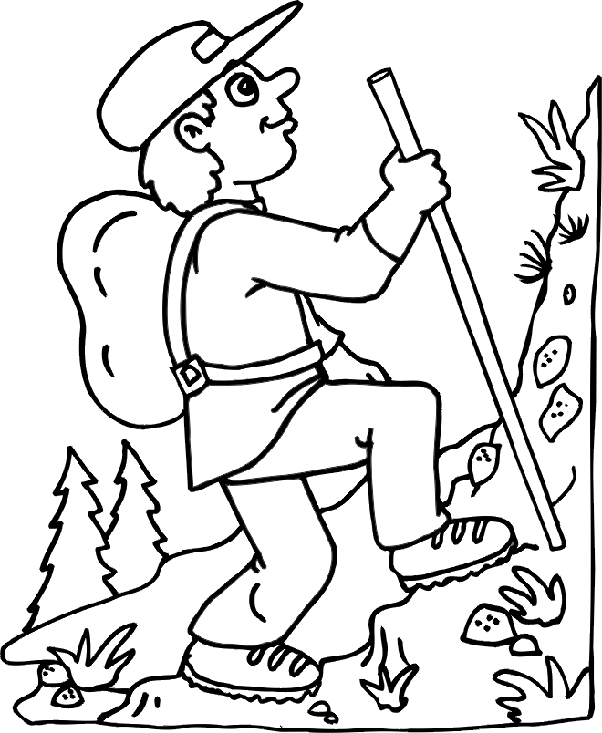 | 1 | Noah is in the lake.
 | 2 | He is riding his mountain bike.
 | 3 | There are some big trees.
 | 4 | There isn’t an animal.
 | 5 | He is sad.

CIRCLE THE CORRECT ANSWER ‘a’ or ‘b’. | 5 x 0.3 = 1.5 marks

1- | Was Kate in the playground yesterday?
a |  | Yes, she did. | b | Yes, she was.
2- | Are your friends outdoors?
a |  | Yes, you are. | b | Yes, they are.
3- | What instrument does she play?
a |  | She plays the cello. | b | Yes, she does.
4- | Are there any green peppers?
a |  | Yes, there are. | b | I only like red peppers.
5- | Is Josie ice skating?
a |  | Yes, they are. | b | Yes, she is.

MATCH A LINE FROM ‘A’ WITH A LINE FROM ‘B’. Write the corresponding letter  from B in the box. | 5 x 0.3 = 1.5 marks

 | A | B |  |  | B
1 | We didn’t |  |  | a | do in the countryside?
2 | Edward and Sarah are |  |  | b | Saturday, Sunday and Monday.
3 | What can you |  |  | c | Ethel’s parents.
4 | The lamp is |  |  | d | on the table.
5 | Carnival is on |  |  | e | study Maths yesterday.

COMPLETE THE TEXT WITH THE WORDS IN THE BOX | 5 x 0.4 = 2 marks

members usually folk computer plays

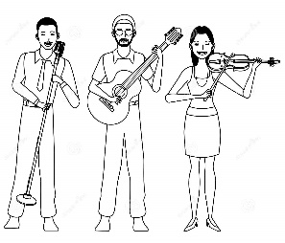 | My favourite band is The Strawberries. They play 1) __________ music. There are three 2) __________ in the band, Greg, Leo and Helen. Greg is the lead singer. Leo 3) __________ the guitar and Helen the violin. They 4) __________ perform at concerts. I watch their music videos on my 5) __________.

WRITING. Write 5 sentences using the words in the chart. Put the verbs in the correct form. | 5 x 0.3 = 1.5 marks

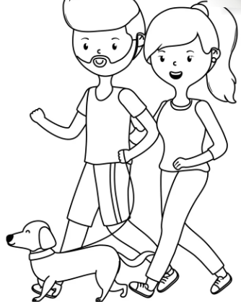 | These are my auntie, Suzy and my uncle, Mark.
 | Uncle Mark / be / police officer.
 | He / not / get up early
 | Because / he / work / the evening.
 | Suzy and Mark / not / have / children.
 | But / they / have / a dog, King.

KD3-02
WRITE: sail: cycle, skip, surf skate park: playground, zoo, city burgers: curry, fish, noodles, chips
CHOOSE: 1-has 2-don’t use 3-some 4-weren’t 5-when
READ AND WRITE: 1-F 2-F 3-T 4-T 5-F
CIRCLE: 1-b 2-b 3-a 4-a 5-b
MATCH A LINE: 1-e 2-c 3-a 4-d 5-b
COMPLETE: 1-folk 2-members 3-plays 4-usually 5-computer

