INSTITUTO CAMBRIDGE – Exams 2024

KIDS 2

NAME:

TIME: 1 hour 30 minutes

2

MARK SET

READ AND NUMBER THE PICTURES | 5 x 0.2 =1 mark

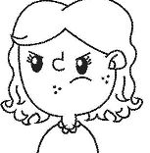 |  | 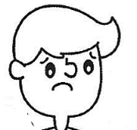 |  | 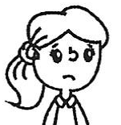 |  |  |  | 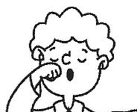

1- She's sad. | 3- She´s hungry. | 5- She´s angry.
2- He's tired. | 4- He´s sad.

WRITE THE WORDS | 5 x 0.2 = 1 mark

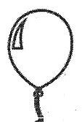 | 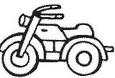 | 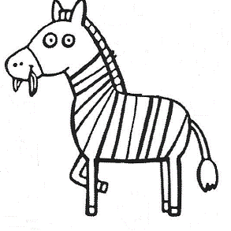 | 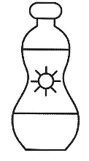 | 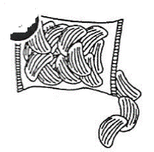
B _ _ _ _ _ _ | _ _ _ _ _ _ _ _E | _ _ _ _ A | S _ _ C_ _ _ _ | _ _ _ _ _S

LOOK AND TICK. Tick the 5 correct sentences. | 5 x 0.2 = 1 mark

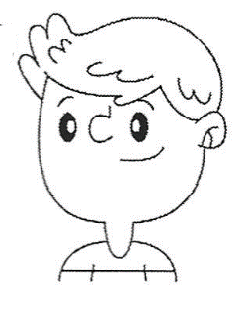 | 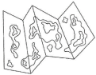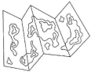  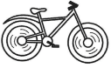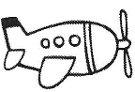 |  | 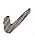 | 0 | These are his maps.
 |  |  |  | 1- | This is her bike.
 |  |  |  | 2- | This is her train.
 |  |  |  | 3- | These are his cameras.
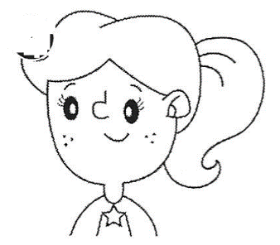 |   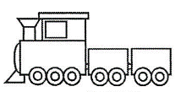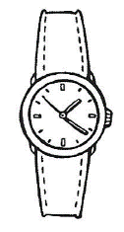 |  |  | 4- | These are her cameras.
 |  |  |  | 5- | This is his bike.
 |  |  |  | 6- | These are his planes.
 |  |  |  | 7- | These are her watches.

READ AND CIRCLE. Look at the map and circle the correct prepositions | 5 x 0.3 = 1.5 marks

 |  |  |  | Library |  |  |  | The school is in front of/opposite the restaurant.
 | School |  |  | Restaurant |  |  |  | The park is behind/between the museum and the swimming pool.
 |  |  |  |  |  |  |  | The museum is above/next to the park.
 |  |  |  |  |  |  |  | The restaurant is behind/opposite the swimming pool.
 |  |  |  | Swimming pool | Park | Museum |  | The library is opposite/next to the restaurant.

READ AND WRITE TRUE OR FALSE (T – F) | 5 x 0.3 = 1.5 marks

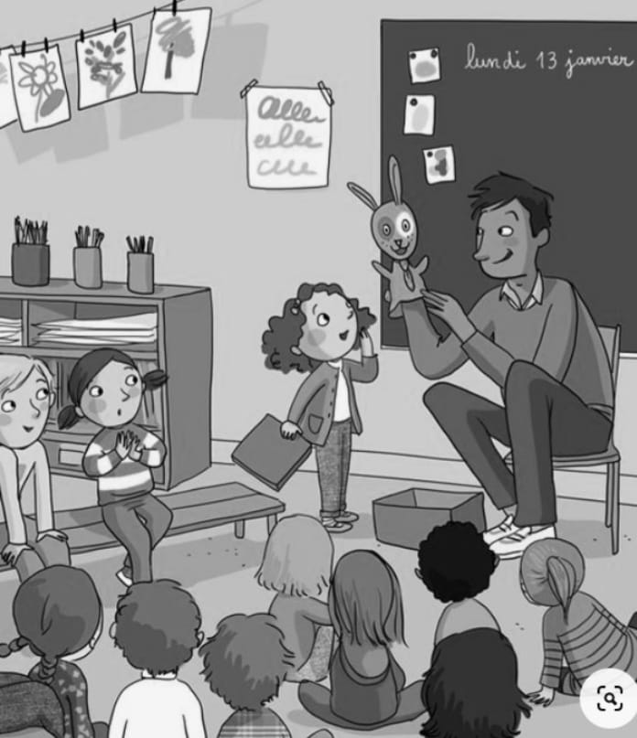 | 1- | The children are at home.
 | 2- | The teacher is writing on the board.
 | 3- | There is a box next to the teacher.
 | 4- | The teacher has got a plane in his hand.
 | 5- | The teacher is angry.

READ AND MATCH. Write the corresponding letter in the box. | 5 x 0.4 = 2 marks

1 | He's a scientist. He isn't a teacher. |  |  | a | 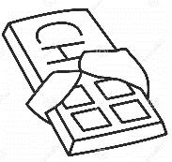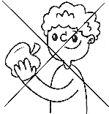
2 | I've got a necklace. I haven't got a board game. |  |  | b | 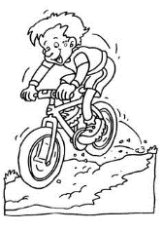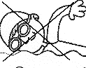
3 | I go mountain biking. I don´t go swimming. |  |  | c | 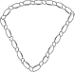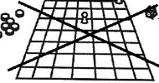
4 | I like chocolate. I don't like fruit. |  |  | d | 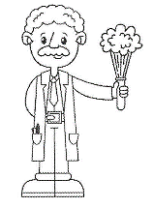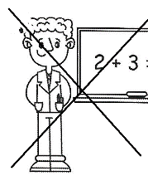
5 | He is doing Geography. He isn't doing PE |  |  | e | 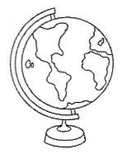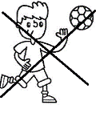

MATCH THE QUESTIONS FROM ‘A’ WITH THE ANSWERS FROM ‘B’. Write  the corresponding number from B in the box. | 5 x 0.4 = 2 marks

 | A | B |  |  | B
1 | What's she doing? |  |  | a | No, thank you.
2 | Does an elephant live in a cave? |  |  | b | She's doing drama.
3 | Are there any museums in your town? |  |  | c | No, I am not.
4 | Would you like some biscuits? |  |  | d | No, it doesn't.
5 | Are you doing English? |  |  | e | Yes, there are.
KD2-02
READ AND NUMBER:5-4-1-3-2
WRITE THE WORDS: 1-balloon 2-motorbike 3-zebra 4-sun cream 5-crisps
LOOK AND TICK: 2-4-5-6-7
READ AND CIRCLE: 1-opposite 2-between 3-next to 4-opposite 5-next to
READ AND WRITE: 1-F 2-F 3-T 4-F 5-F
READ AND MATCH: 1-d 2-c 3-b 4-a 5-e
MATCH: 1-b 2-d 3-e 4-a 5-c

