INSTITUTO CAMBRIDGE – Exams 2024

KIDS 1

NAME:

TIME: 1 hour 30 minutes

1

MARK SET
READ AND TICK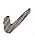OR CROSS. Put a tick or a cross in the box. | 5 x 0.2 = 1 mark

1 | This is a sandwich | 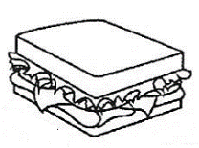 |  |  | 4 | This is a plant | 
2 | This is a spider | 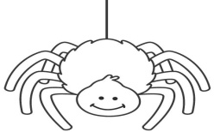 |  |  | 5 | This is a robot | 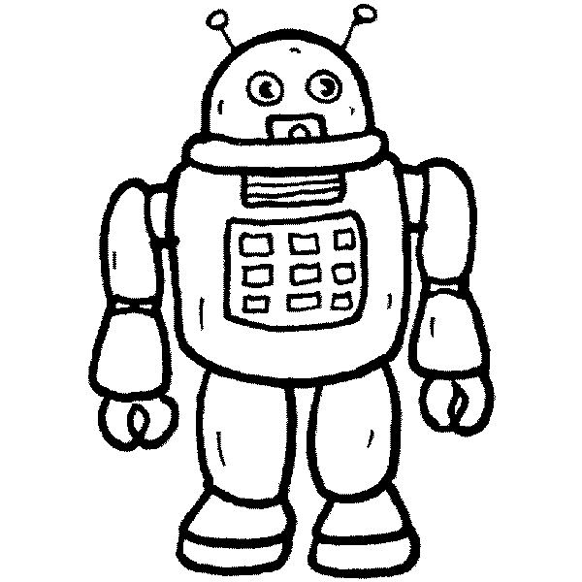
3 | These are shoes | 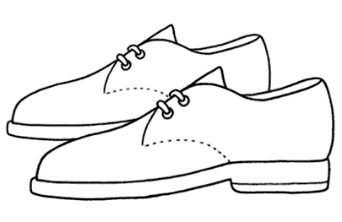 |  |  | 6 | This is a mouth | 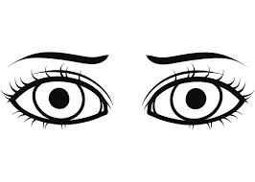

READ AND COLOUR THE PICTURE | 4 x 0.25 = 1 mark

Her hair is black  Her skirt is yellow and orange.  Her shirt is purple.  Her nose is pink. | 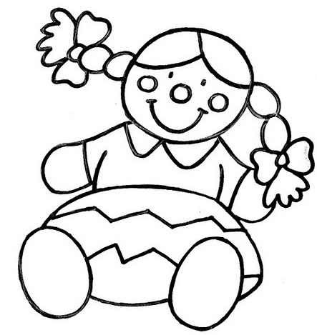

DRAW THE ANIMAL AND CIRCLE THE CORRECT WORDS | 5 x 0.4 = 2 marks

THIS IS A RABBIT
1- It is big/small.
2- It’s got two ears/tails.
3- It can jump/play football.
4- It hasn’t got arms/legs.
5- It can’t run/rollerblade.

MATCH THE SENTENCES | 5 x 0.4 = 2 marks

1 | Finn can | a- a sister
2 | Norman has got | b- ten
3 | I’m | c- big
4 | I don’t like | d- ride a horse
5 | Cows are | e- snakes

READ AND DRAW ☺ OR ☹ | 5 x 0.4 = 2 marks

I like chocolate and bananas.
I don’t like eggs.
I don’t like fish.
I like sandwiches.

 | 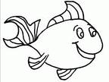 | 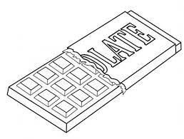 | 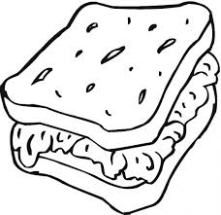 | 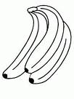
1- | 2- | 3- | 4- | 5-

ANSWER. Answer the questions using the words in the box. | 5 x 0.4 = 2 marks

No, I can’t - Yes, I have - In the garden - Yes, I do - It’s a door -

1- | Where is dad?
2- | Have you got a pet?
3- | Can you play tennis?
4- | What’s this?
5- | Do you like milk?

KD1-01
READ AND TICK: 2) 3) 4) 5) 6)
DRAW AND CIRCLE: 1 small 2 ears 3 jump 4 arms 5 rollerblade
MATCH: 1d 2a 3b 4e 5c
READ AND DRAW: 1☹ 2☹ 3☺4☺5☺
ANSWER: 1 In the garden 2 Yes, I have 3 No, I can’t 4 It’s a door
5 Yes, I do

