**2024 KIDS 3 SAMPLE ORAL EXAM**

# PART 1

1. **QUESTIONS BASED ON THE PICTURE**

Examiner: Hello…. Please, sit down. How are you?

Look at this picture, please.

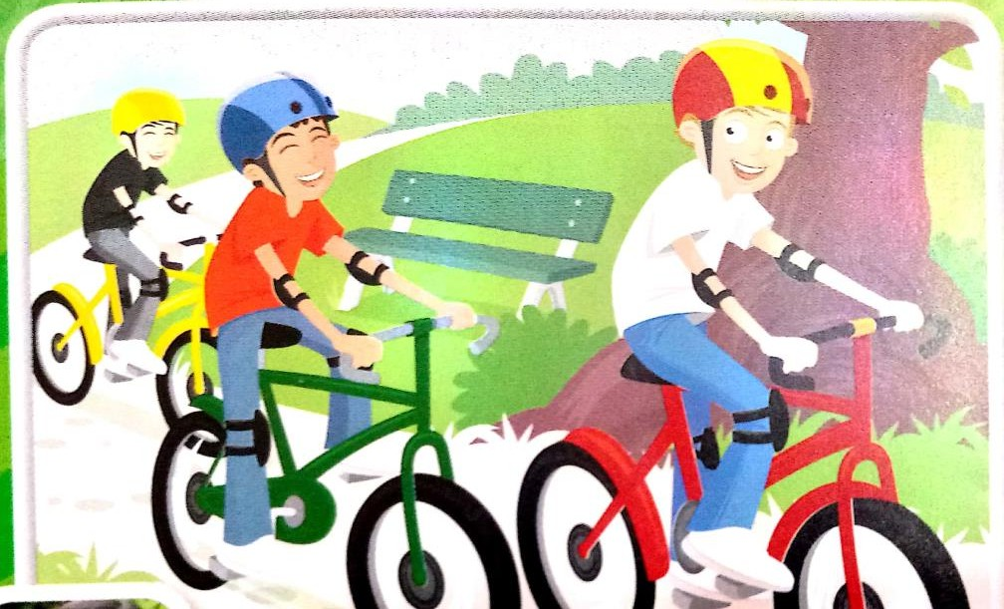

-How many boys are there? There are three.

-What are they doing? They are cycling.

-Are they swimming? No, they aren’t. -Are they cycling? Yes, they are.

-Have they got bikes? Yes, they have,

-What colour are their bikes? Yellow, red and green.

-Where are they cycling? They are in the park.

-Are they happy? Yes, they are. -Are they sad? No, they aren’t.

-Are there any girls in the picture? No, there aren’t.

-Do they like cycling? Yes, they do.

-Are they wearing trainers / shoes? Yes, they are/ No, they aren’t.

-Can you ride a bike? Yes, I can. / No, I can’t.

# PERSONAL QUESTIONS

* + How old are you?
  + What’s the time?
  + Can you skip/ do judo/play chess / cycle/ skateboard/ surf?
  + Have you got a guitar / violin / flute?
  + Is your bother / dad/ mother eating ice cream / cooking?
  + Do you like prawns / burgers / noodles / fish and chips/ hip hop/ reggae?
  + What time do you get up / have dinner / have a shower/go home / do your homework?
  + Do you go swimming/ read comics / do karate/ play the piano/ play boardgames / do jigsaws / play video games? When? Where?
  + Does your mother get up early / work/ do sport?
  + Does your sister/ friend/ father play the violin /sing / have dance lessons?

***NOTE: We will not necessarily ask all the questions in Part A and B***

# PART 2

Questions on the reader: *The Selfish Giant*